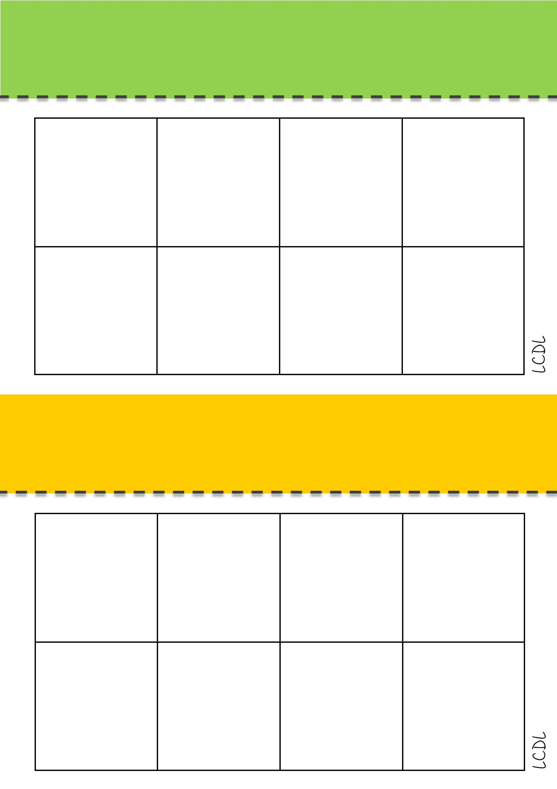

**1**

**4**

**6**

**2**

**5**

**6**

**2**

**5**

3

**1**

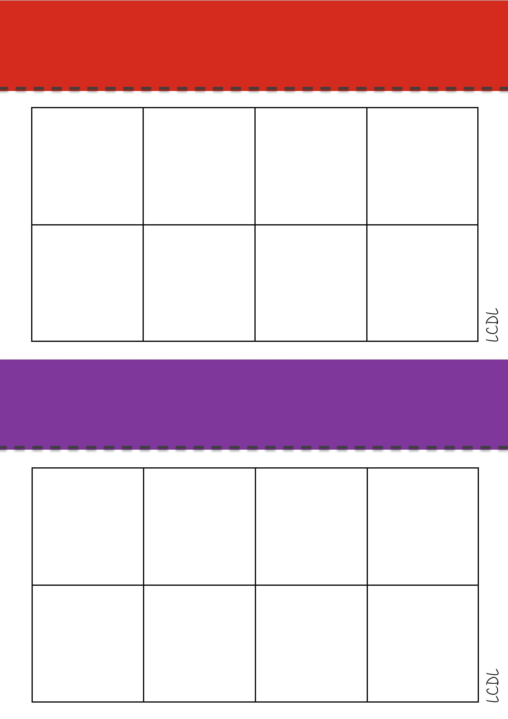

**6**

**2**

**5**

**4**

3

**6**

**4**

**5**

**1**

3

|  |  |
| --- | --- |
| 1 | 2 |
| 3 | 4 |
| 5 | 6 |
| 7 | 8 |
| 9 | 10 |

